**WEEK 5**

PART – A

Q1.

CODE

#include<stdio.h>

void main()

{

int marks;

printf("Enter the total marks percentage");

scanf("%d", &marks);

if (marks>=75)

printf("FIRST DIVISION");

else if (marks<75 && marks >65)

printf("SECOND DIVISION");

else if (marks<65&& marks>=55)

printf("THIRD DIVISION");

else if (marks<55)

printf("FOURTH DIVISION");

}

OUTPUT

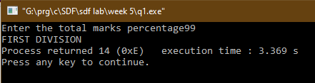

Q2.

CODE

#include<stdio.h>

void main()

{

int a,b,c;

printf("enter the first no");

scanf("%d",&a);

printf("enter the first no");

scanf("%d",&b);

printf("enter the first no");

scanf("%d",&c);

if (a>b && a>c)

{

if (b>c)

{

printf("the nos in ascending order are :- %d < %d < %d ", c,b,a);

}

else if (b<c)

{

printf("the nos in ascending order are :- %d < %d < %d ", b,c,a);

}

else if (b==c)

{

printf("the nos in ascending order are :- %d = %d < %d ", b,c,a);

}

else if (a==b==c)

printf("all the 3 nos are equal");

}

else if (b>a && b>c)

{

if (a>c)

{

printf("the nos in ascending order are :- %d < %d < %d ", c,a,b);

}

if (a<c)

{

printf("the nos in ascending order are :- %d < %d < %d ", a,c,b);

}

else if (a==c)

{

printf("the nos in ascending order are :- %d = %d < %d ", a,c,b);

}

else if (a==b==c)

printf("all the 3 nos are equal");

}

else if (c>a && c>b)

{

if (a>b)

{

printf("the nos in ascending order are :- %d < %d < %d ", b,a,c);

}

if (a<b)

{

printf("the nos in ascending order are :- %d < %d < %d ", a,b,c);

}

else if (a==b)

{

printf("the nos in ascending order are :- %d = %d < %d ", a,b,c);

}

else if (a==b==c)

printf("all the 3 nos are equal");

}

}

OUTPUT

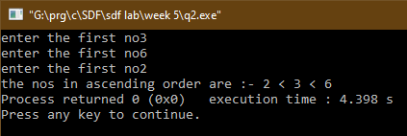

Q3.

CODE

#include<stdio.h>

void main()

{

int a,b,c;

printf("enter the length of first side:- ");

scanf("%d",&a);

printf("enter the length of second side:- ");

scanf("%d",&b);

printf("enter the length of third side :- ");

scanf("%d",&c);

if (a+b>c && b+c>a && a+c>b)

{

printf("the triangle is valid");

}

else printf("the triangle is not valid");

}

OUTPUT

Q4.

CODE

#include<stdio.h>

void main()

{

int age;

printf("ENTER THE Age");

scanf("%d",&age);

if (age <18)

printf("the person is not suitable for job");

else if (age>=18 && age <=66)

printf("the person is suitable for job");

else if (age >66)

printf("the person is not suitable for job");

}

OUTPUT

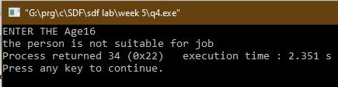

Q5.

CODE

#include<stdio.h>

void main()

{

int a,b,c;

printf("enter the length of first side:- ");

scanf("%d",&a);

printf("enter the length of second side:- ");

scanf("%d",&b);

printf("enter the length of third side :- ");

scanf("%d",&c);

if (a==b&&b==c&&c==a)

printf("the triangle is an equilateral triangle ");

else if (a==b||a==c||b==c)

printf("the triangle is an isosceles triangle");

else if (a!=b!=c)

printf("the triangle is a scalene triangle ");

}

OUTPUT

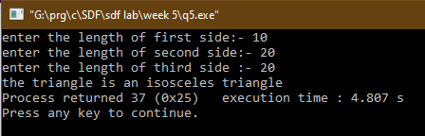

PART – B

Q1.

CODE

#include<math.h>

#include<stdio.h>

void main()

{

int a=0,b=0,c=0;

float D,d1,d2;

printf("Enter the value of coefficient of x^2 ");

scanf("%d",&a);

printf("Enter the value of coefficient of x ");

scanf("%d",&b);

printf("Enter the value of constant term ");

scanf("%d",&c);

D=(b*b)-(4*a*c);

if (D<0)

{

printf("THE ROOTHS OF THE EQUATION %dx^2 + %dx + %d ARE NOT POSSIBLE", a,b,c);

exit (0);

}

d1=(-b+sqrt(D))/(2*a);

d2=(-b-sqrt(D))/(2*a);

if (b<0)

printf("the roots of the equation %dx^2 %dx + %d are %0.2f and %0.2f ", a,b,c,d1,d2);

else if (c<0)

printf("the roots of the equation %dx^2+%dx %d are %0.2f and %0.2f ", a,b,c,d1,d2);

else printf("the roots of the equation %dx^2 + %dx + %d are %0.2f and %0.2f ", a,b,c,d1,d2);

if (D==0)

printf("\n the roots are equal");

}

OUTPUT

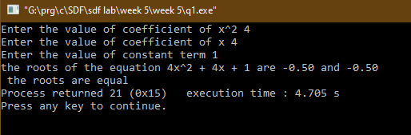

Q2.

CODE

#include<stdio.h>

void main()

{

float cp,sp,p,l;

printf("ENTER THE COST PRICE :- ");

scanf("%f", &cp);

printf("ENTER THE SELLING PRICE :- ");

scanf("%f", &sp);

if (sp>cp)

{

p=((sp-cp)/cp)*100;

printf("the profit on the item is %0.2f ",p);

}

if (sp<cp)

{

p=(((sp-cp)/cp)*100)*(-1);

printf("the loss on the item is %0.2f" , p);

}

}

OUTPUT

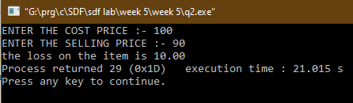

Q3.

CODE

#include<stdio.h>

void main()

{

int m,p,c,t,t1;

printf("Enter the marks in Maths :- ");

scanf("%d",&m);

printf("Enter the marks in Physics :- ");

scanf("%d",&p);

printf("Enter the marks in Chnistry :- ");

scanf("%d",&c);

t=m+p+c;

if (m>=60)

{

if (p>=55)

{

if (c>=50)

{

if (t>=180)

{

printf("You are Eligible");

}

else if ((m+p+t)>=140)

printf("You are Eligible");

}

else

{

printf("You are not Eligible");

exit(0);

}

}

else

{

printf("You are not Eligible");

exit(0);

}

}

else

{

printf("You are not Eligible");

exit(0);

}

}

OUTPUT

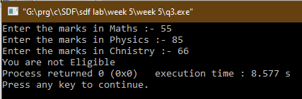

Q4.

CODE

#include<ctype.h>

#include<stdio.h>

void main()

{

char a;

printf ("enter a character :- ");

scanf("%c",&a);

if (isalpha(a))

{

printf("This is an alphabet");

}

else if (isdigit(a))

{

printf("This is a digit");

}

else printf("the character is a special character");

}

OUTPUT

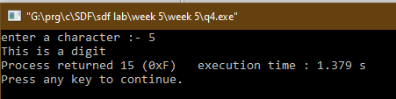

Q5.

CODE

#include<stdio.h>

void main()

{

int units;

float tot;;

printf("Enter the no of units:- ");

scanf("%d",&units);

if (units<=50)

{

tot=0.5*units;

tot=tot+0.2*tot;

printf("the total bill is :- %0.2f",tot);

}

if (units>50 && units<=150)

{

tot=(0.5*50)+(0.75*(units-50));

tot=tot+0.2*tot;

printf("the total bill is :- %0.2f ",tot );

}

if (units>150 && units<=250)

{

tot=0.5*50+0.75*100+1.30*(units-150);

tot=tot+tot*0.2;

printf("the total bill is :- %0.2f ",tot );

}

if (units>250)

{

tot=0.5*50+0.75*100+1.30*100+1.50*(units-250);

tot=tot+tot*0.2;

printf("the total bill is :- %0.2f ",tot);

}

}

OUTPUT

